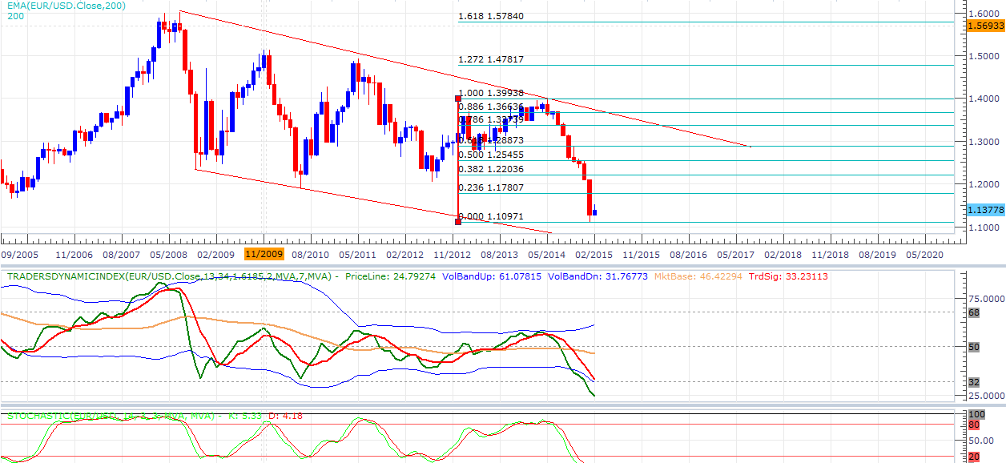
EUR/USD Big Picture Week 23/2/15 – 28/2/15

Descending channel shown on the monthly chart that started back in 2008, with a blue candle forming could this month be the start of a retracement of the current swing high-low or it could potentially continue down towards the channel support.
TDI and stoch in the oversold area supporting the idea that it might retrace and head bullish
Key levels:
Month open: 1.12771
PML: 1.10971
PMH: 1.20992

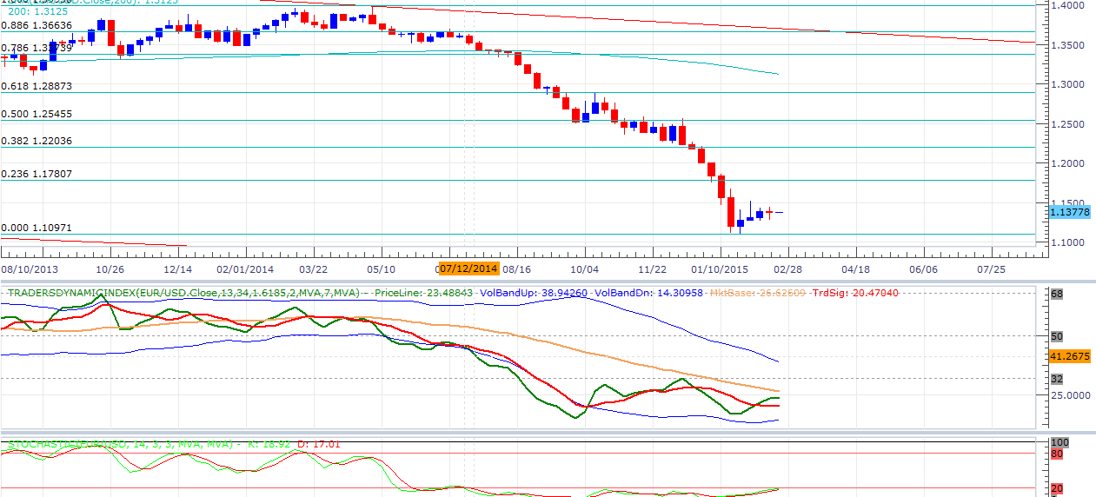
Weekly

The previous week we saw some indecision in price with a doji forming.
Tdi is in the oversold region although we are seeing a potential hook back which brings the question whether this pair will continue and break the recent swing low, or retrace the initial swing and continue with the monthly bullish candle.
Key levels:
Week open: 1.13778
PWL: 1.12789
PWH: 1.14502

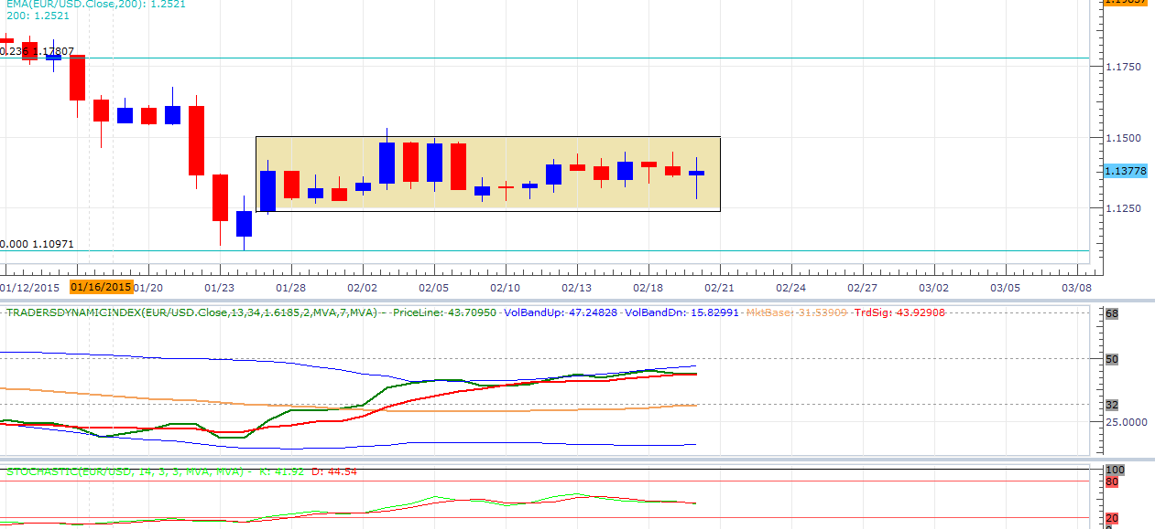
Daily

The daily chart seems to be stuck in a range for the last 20 days, with the TDI at the top of the bands and heading up we could see a combination of a break in both the consolidation box and a cross on the TDI being a signal that maybe this pair will continue down and therefore negate our retracement possibility. Stoch is heading down but not yet oversold.
Key levels:
1.10971 support of previous swing low
1.17807 .236 fib level
PDL: 1.12789
PDH: 1.14298

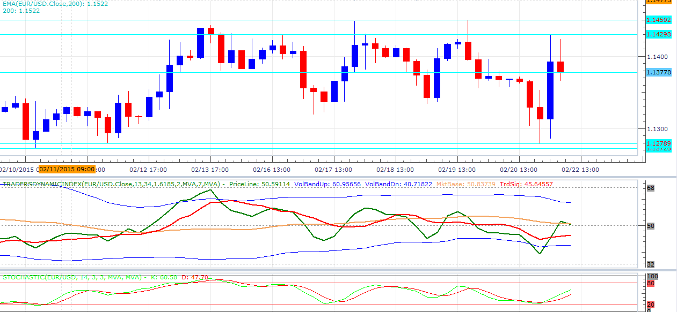
4 Hour

As we are in a range, We can only expect to play the S/R bounces or TDI setups within the range until the either the low or the high is broken.
If the low is broken we can expect a continuation of the monthly down leg to potentially the 1.06-1.07 area?

